Dashboard Reporting
Friday, November 7, 2025

Dashboard and Tile reports are the one and the same
They give a quick snapshot or quick view of data
For more detailed view of data, we built Canvas or Table Report

Create dashboard report like this Canvas Report
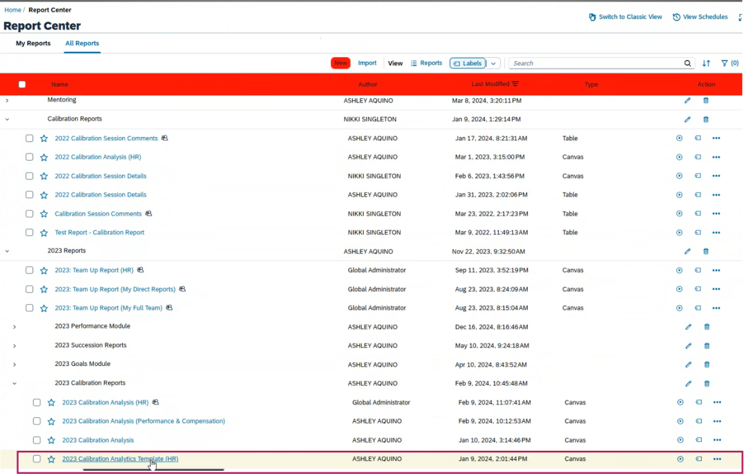

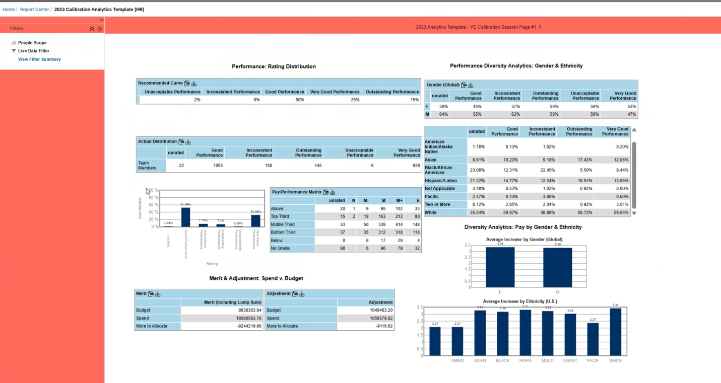

Manage Dashboard
